Creating a Custom Zappy Template Action
Version: 4.0.1

An action is the building block of a process automation. Zappy Task Editor comes with various built-in Template Actions, as well as dedicated Actions (PDF, Mail, Excel, Word, Chrome etc.). You can read The Zappy Activities Guide for more details and examples. Additionally, you can create custom activities to better automate processes based on your needs.
There are two major steps required to create a custom action:
- Writing the custom action code.
- Adding the external assembly (.dll or nupkg) in Zappy Task Editor.

Note:
In order to write the code for your custom action you need to install Microsoft Visual Studio with the .NET desktop development workload.

You can write the code for your custom action either deriving from existing Template Action or follow the steps below and customize accordingly.

Writing the Custom Action Code
To better understand how to write the code for a custom action, we are going to create one action which asks the user for a String, then Display it in the Message Box.
We are adding video which shows the following steps.

- Launch Microsoft Visual Studio.
- Click File > New >Project… (shortcut: Ctrl + Shift + N). The New Project window is displayed.
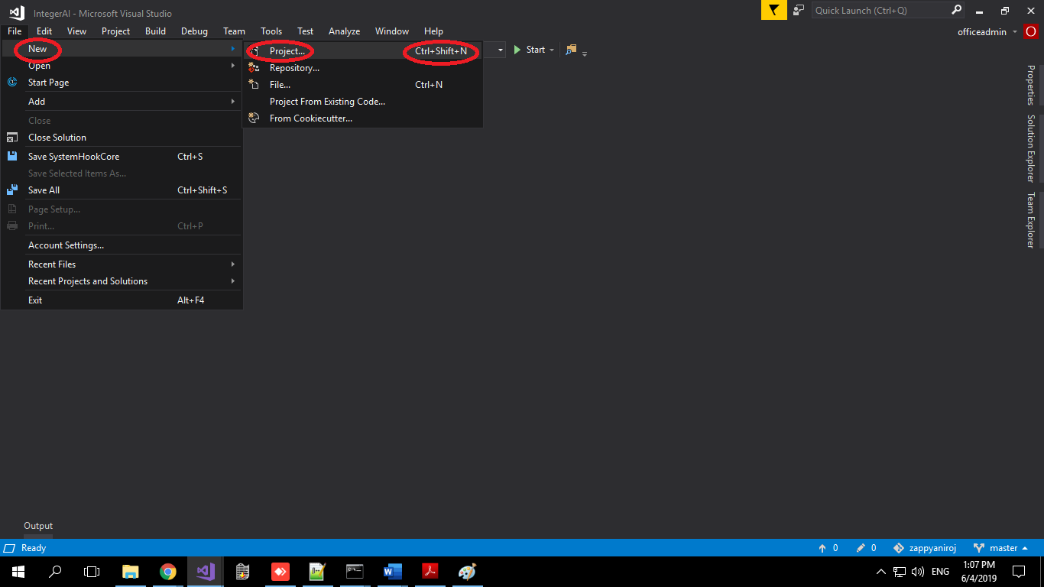
Create Class Library
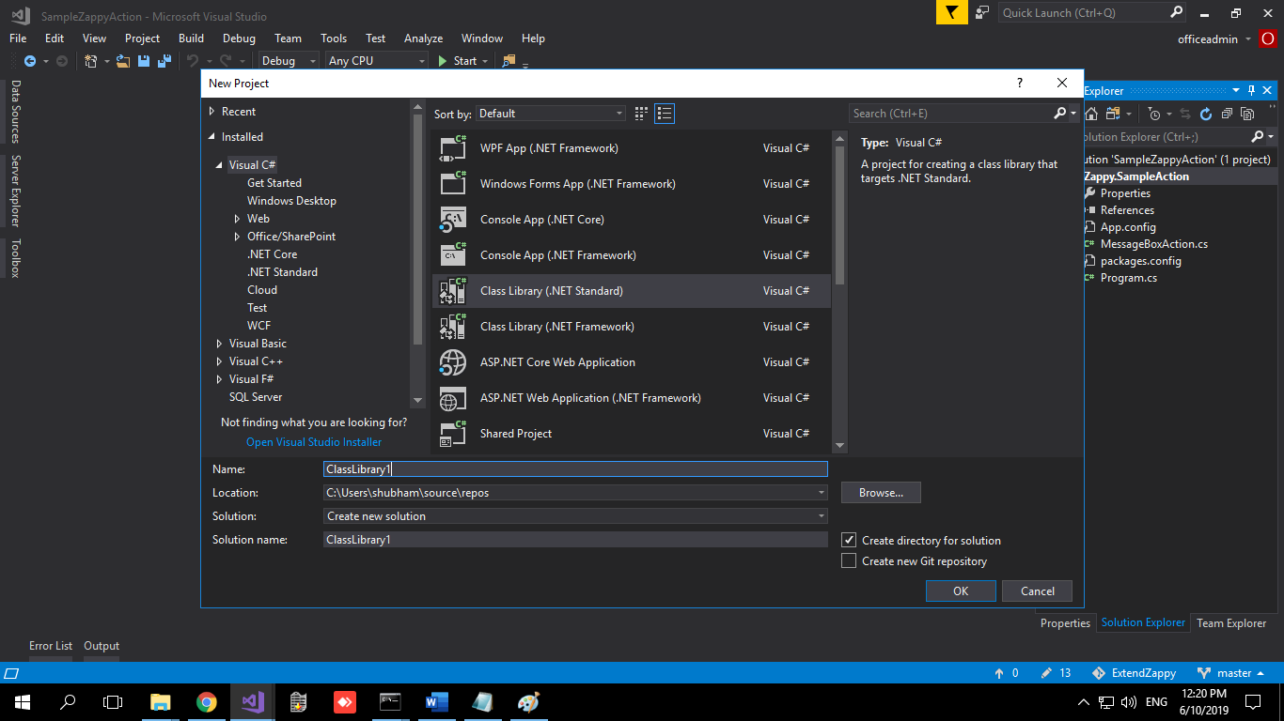

- Click Visual C#. The list of all dependencies using C# is displayed. Select Class Library (.Net Framework). Always start the name your custom Project with Zappy. (Ex: Zappy.NewAction1)
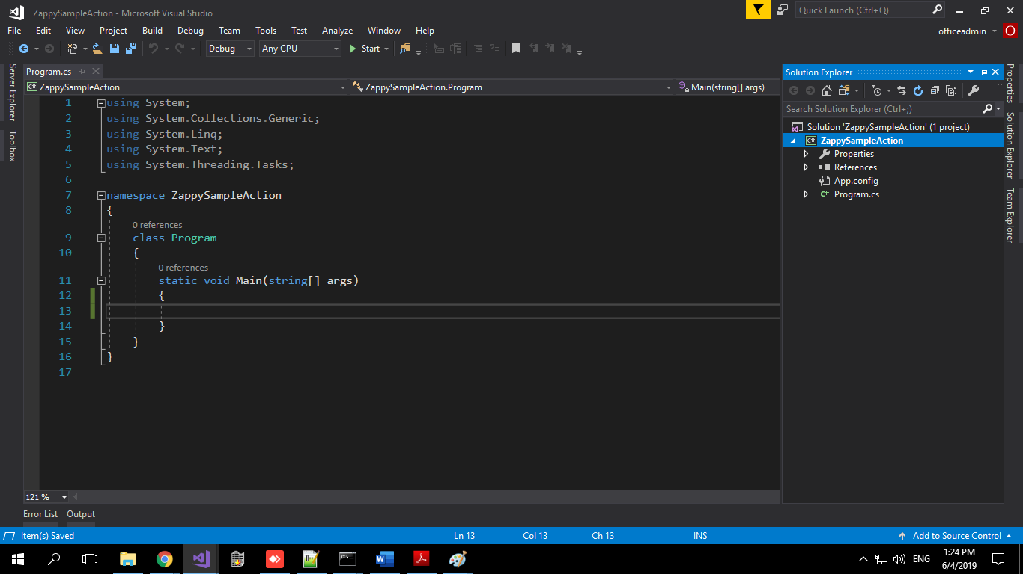
- .cs file is created by default.
- In Menu bar, click on the Project > Manage Nuget Package for Solution, Click on Browse and search for Zappy.SharedInterface. Select to add.

Add Nuget package manager.
Step 1:- Right Click on project.
Step 2:- Click the Manage Nuget Package.
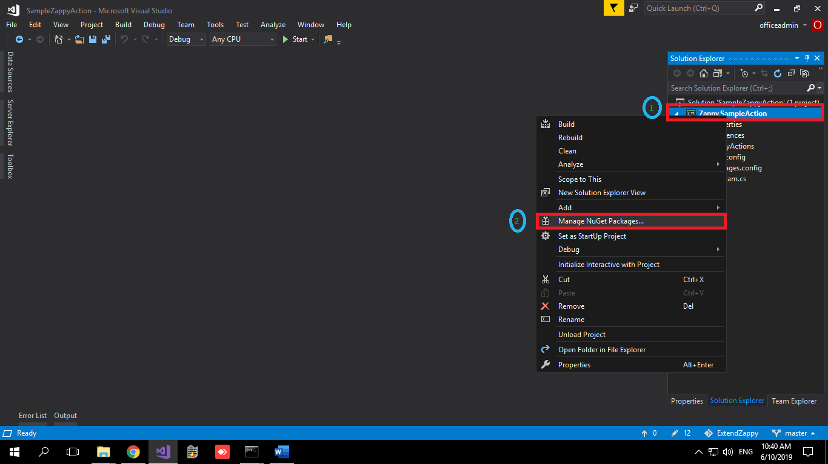

Clicking on the Manage Nuget Package gives you this screen
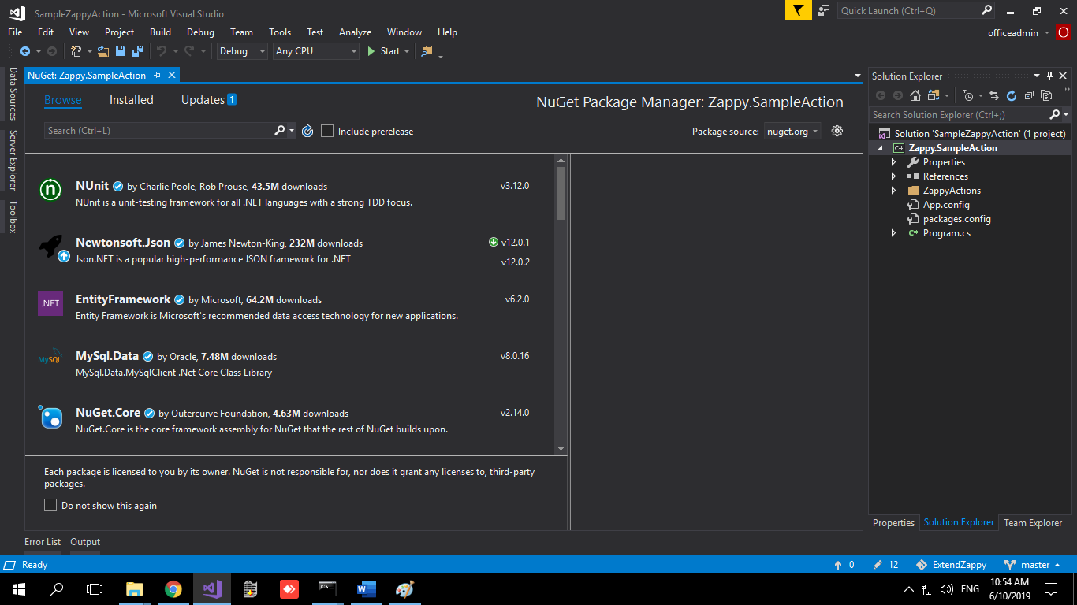
Step 1: - Click on Browser button.
Step 2: - Search Zappy.SharedInterface NuGet package.
Step 3: - Click Zappy.SharedInterface NuGet package.
Step 4: - Click on Install button.
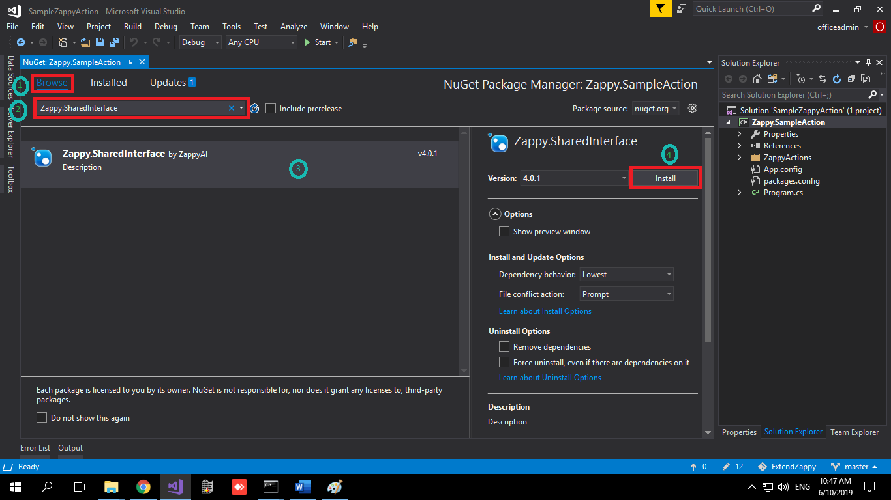

Step 1: Right Click on project.
Step 2:- Click on Add.
Step 3:-Click on Class.
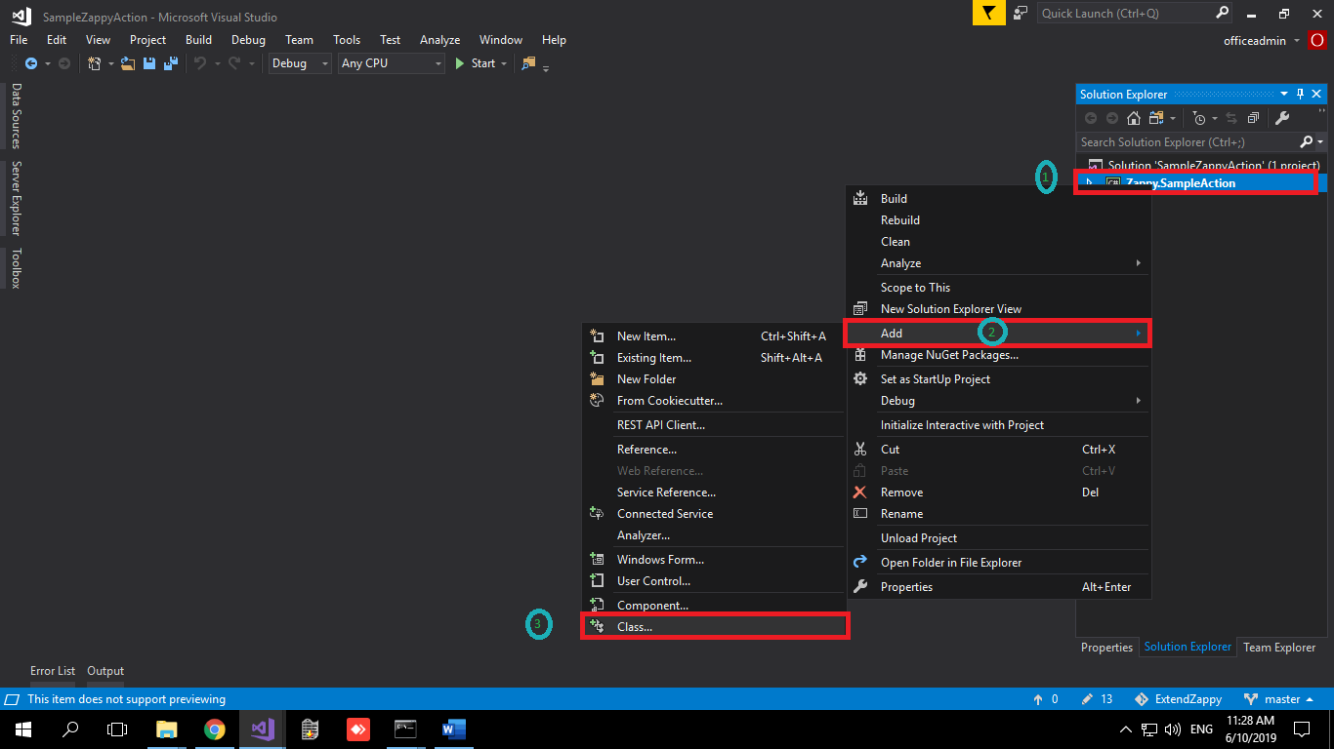
Clicking on the Class gives you this screen
Step 1: - Rename the .cs file name.
Step 2: - Click Add button.
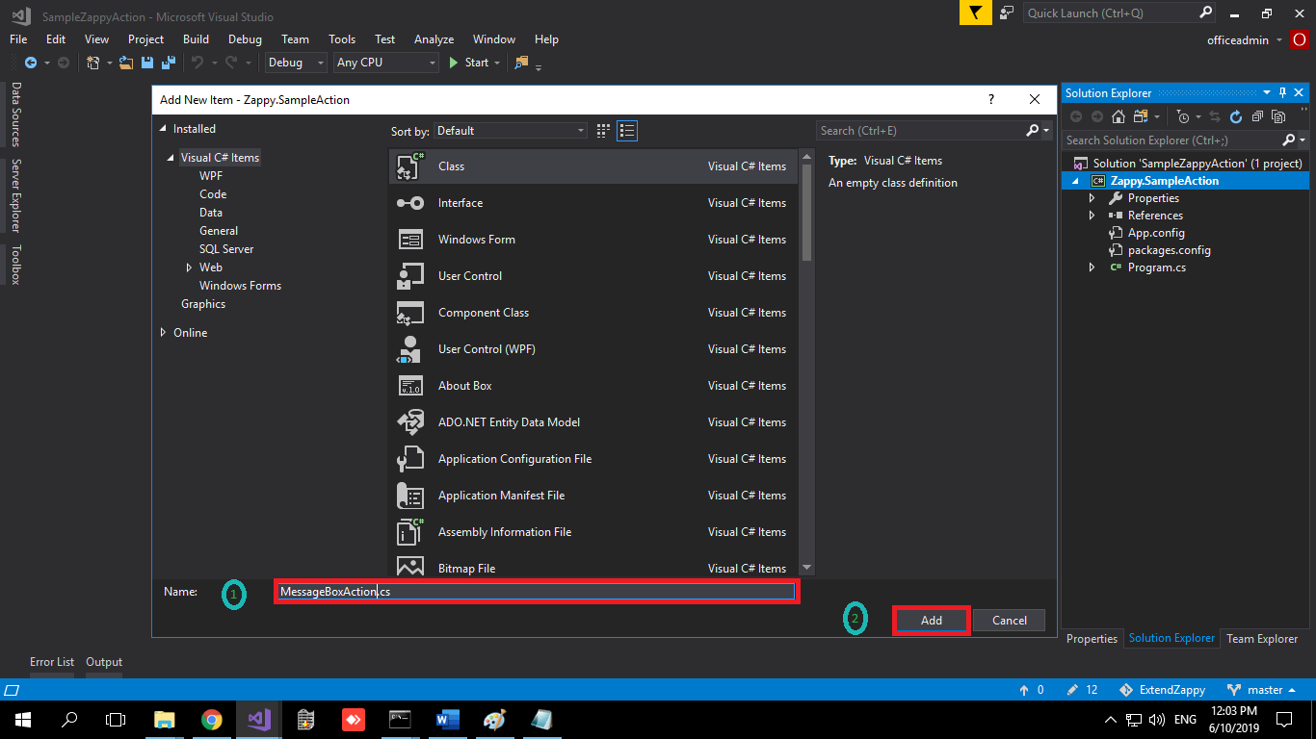
Clicking on the Add button gives you this screen.
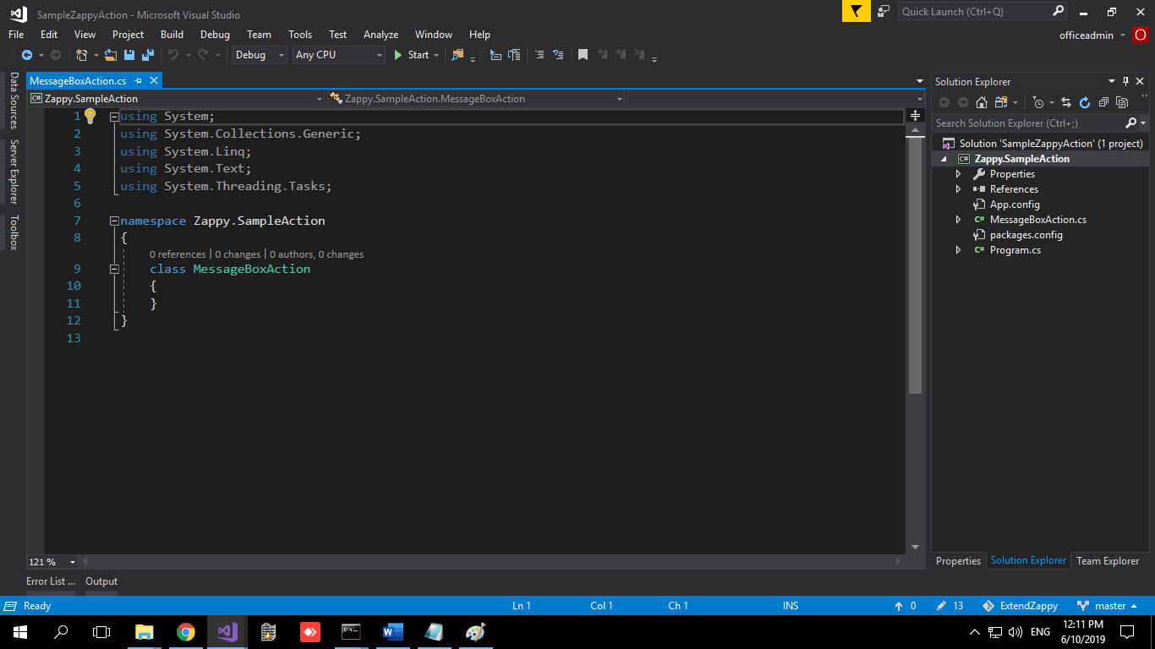

- In the Using directive, add the following:
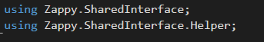
- Write the code for your custom activity. In this case, it looks something like this:
We are adding code for SampleZappyAction (a text box that accepts string and displays it).
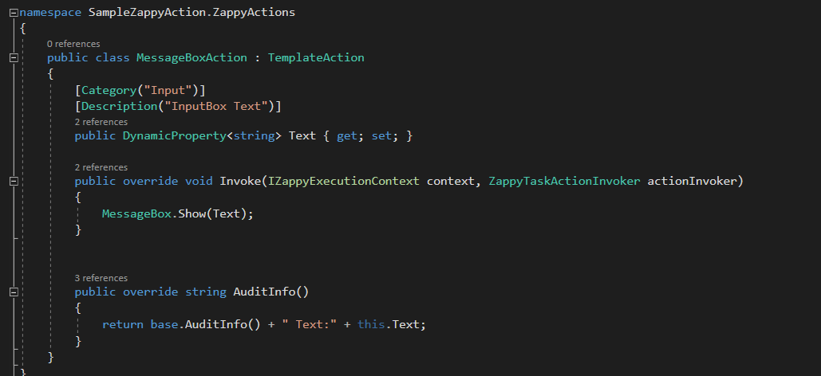

Adding the external assembly (.dll or nuget Package) in Zappy Task Editor

1] Adding .dll File in Zappy Task Editor
1.Right Click on Zappy Icon > Option > Nuget Manager

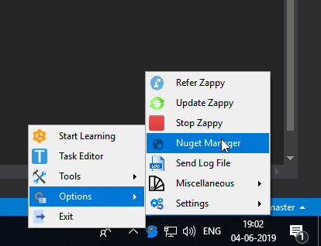

2.Click on Install Nuget Package Button
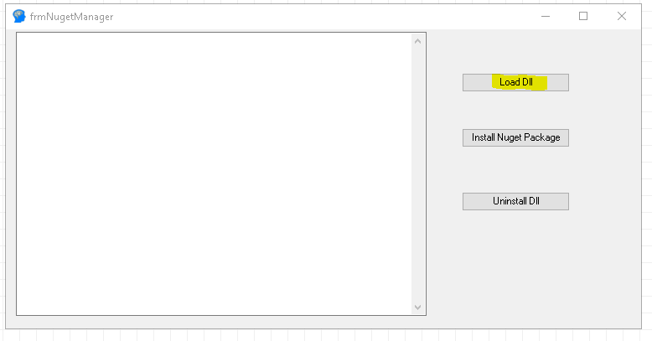
- Select the *.dll file which you want to Load.

- After Successfully Load the *.dll file, launch Zappy Task Editor. Activity is added at the End of Activities.
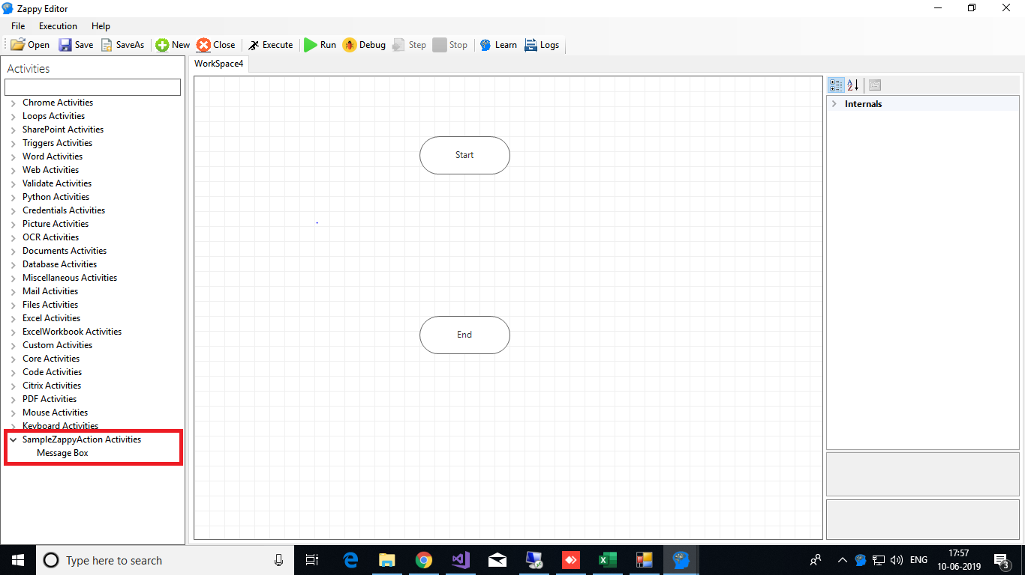

To create Nuget package: https://docs.microsoft.com/en-us/nuget/create-packages/creating-a-package
2] Adding Nuget Package in Zappy Task Editor
- Right Click on Zappy Icon > Option > Nuget Manager

- Click on Install Nuget Package Button
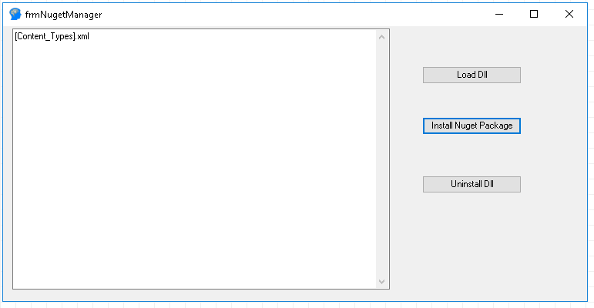
3. Select the *. nupkg file which you want to Install.

4. After Successfully Installing the Package, launch Zappy Task Editor. Activity is added at the End of Activities.

